PSSI Science Project Reporting Template

️ | The PSSI Implementation Team is compiling a technical report to demonstrate the important research and advancements made by the Science Branch through the PSSI funding. The technical report will include a 3-4 page summary (including graphics and figures) for each project to show their key results and findings. Please fill in the following fields and sections for your project to be included in the report. Feel free to include and draw from any reports or presentations previously created through your research.  A plain language science bulletin will also be created to follow up on last year’s “DFO Pacific Region Science Bulletin, 2024. New research and monitoring for Pacific salmon and their ecosystems.” While the first bulletin introduced project backgrounds, methods, and timelines, this new bulletin will highlight the projects’ results, key findings, and conclusions with links to reports and data available. The bulletin will include a 1-2 page summary for each project gleaned from the content entered below.  ️ Completed forms are due January 7, 2026.  *Please include or send separately any graphics or pictures (with photo credits) that will help promote the projects.

PART 1: PROJECT METADATA

General Project Information
Project ID (number) | Project Title
2416 | Monitoring and predicting the exposure of Pacific salmon to harmful algal biotoxins
Project Leads | Collaborations and External Partners
Andrew Ross | Cermaq Canada (Aquaculture Transition/CSRF)  Pacific Salmon Foundation (Citizen Science Program/CSRF)  Snuneymuxw First Nation
Location (if applicable)
Institute of Ocean Sciences

Geographic and Stock Information
Salmon species (if applicable) | Waterbodies (if applicable)
Chinook | Barkley Sound
Life history phases (if applicable) | Region
Juvenile/Early Marine | WCVI
Stock (if applicable) | Population (if applicable)
Sarita, Robertson | WCVI
Conservation Unit (if applicable)
Click or tap here to enter text.

🧰 PART 2: PROJECT METRICS

Project Outputs
Include any anticipated outputs denoted as (in progress). Please include links to any outputs available online so they can be referenced in the report.
List scientific publications and technical reports (with links)
Ross, A.R.S., Ip., B., Mueller, M., Surridge, B., Hartmann, H., Hundal, N., Matthews, N., Shannon, H., Hennekes, M., Sastri, A., and Perry, R.I. (2025). Seasonal monitoring of dissolved and particulate algal biotoxins in the northern Salish Sea using high performance liquid chromatography and tandem mass spectrometry. Harmful Algae 145, 102854 (Journal Article describing method for measuring biotoxins in sea water; published). https://www.sciencedirect.com/science/article/pii/S1568988325000563

Ross, A.R.S., Matthews, N., Mueller, M., et al. Harmful Algal Biotoxin Data Collected from the DFO-PSSI Follow the Fish Project, 2023-2025 (Data Report; in progress).

Mueller, M. et al. Exposure of juvenile west coast Vancouver Island Chinook salmon to harmful algal biotoxins in Barkley Sound (Journal Article describing the key findings of this project; in progress).

List datasets generated (with links)
Regional Biotoxin Database (in progress).
Describe dataset locations and data management systems
Ocean Sciences Division (OSD) Data Archive (DOS Shell).
List code, programs, or other software created (with links)
N/A
List communication or social media products
Ross, A.R.S., Loseto, L. 2025. Monitoring biotoxins and contaminants and their impacts on WCVI Chinook salmon. Follow the Fish Newsletter Volume 3, 12 p. (Government of Canada publication).
https://publications.gc.ca/collections/collection_2025/mpo-dfo/Fs141-15-2025-3-eng.pdf

List and describe field work completed
Monthly collection and filtration of water samples for algal biotoxin analysis at 5 krill survey sites in Barkley Sound, and collection and dissection of juvenile WCVI Chinook salmon tissues for biotoxin analysis at salmon survey locations close to krill survey sites, from July 2023 to November 2025.

List and describe samples collected/analyzed (number of samples)
Monthly sea water samples were collected at up to 5 locations (Swale, Coaster, Mackenzie, Robbers, and/or Sarita) from July 2023, March 2024, and February 2025 to November each year by the krill survey team (Kelly Young et. al) who filtered them on board the R/V Alta to obtain a total of 117 filtrate and 117 filter samples. These samples were analyzed to determine the spatial and temporal distributions of dissolved, particulate, and total algal biotoxins (Ross et al., 2025a) in Barkley Sound.

Tissues from 34 purse-seined juvenile Chinook salmon caught at 3 locations (Village Reef, Kirby Point, and Sarita Bay) by the salmon survey team (Jessy Bokvist et al.) on the R/V Nita Maria from July to September 2023 were pooled to obtain 10 gill and 7 liver samples. These were analyzed for harmful algal biotoxins using a method developed during this project (Mueller et al. in preparation).

Tissues from 159 purse seined fish caught at 5 locations (Hand and Turtle Islands, Village Reef, Nanat Islet, and Sarita Bay) by the salmon survey team (Jessy Bokvist et al.) on the R/V Nita Maria from May to September 2024 were also pooled to obtain 59 gill and 59 liver samples. Of these, 14 pooled gill and 26 pooled liver samples from 60 fish caught at 3 locations (Village Reef, Nanat Islet, and Sarita Bay) from June to September 2024 were analyzed for harmful algal biotoxins based upon when and where biotoxins were measured in the surrounding sea water.

To summarize, a total of 117 water samples and 193 fish were collected in Barkley Sound for this project. These generated 117 filter and 117 filtrate samples, all of which were analyzed for biotoxins. They also generated a total of 69 pooled gill and 66 pooled liver samples, of which 24 gill and 33 liver samples were analyzed for harmful algal biotoxins and the results compared with those for sea water.

List and describe large capital assets or equipment acquired
N/A

PART 3: WRITTEN CONTENT

Highlights
Please summarize in 2-3 bullets:
- The main idea of the project
- Key findings
- Implications of these findings for salmon and decision-makers
- For a more technical audience, but still as plain language as possible
- to assess the risk posed by harmful algal biotoxins to juvenile WCVI Chinook in their critical habitat.
- juvenile WCVI Chinook salmon are exposed to and take up harmful algal biotoxins in Barkley Sound.
- biotoxins known to harm fish peak in summer/fall in Barkley Sound in both water and fish tissues.
- results suggest that biotoxin exposure/impacts can be mitigated e.g. via timing of hatchery releases.

Background
Please provide 1-2 paragraphs to summarize
- The relevant biological, environmental, and/or management context
- What knowledge gap or demand were you trying to fill?
- Collaboration and partner relationships
Biotoxins produced by harmful algae are know to cause illness and mortality in marine animals including juvenile fish (Lefebvre et al., 2005). Regular monitoring of harmful algal biotoxins in B.C. coastal waters since 2020 (Ross et al., 2025b) has revealed significant correlations between climate variables (e.g. water temperature) and the concentrations of these toxins in areas known to be frequented by Pacific salmon. These include at-risk WCVI Chinook salmon populations, for which harmful algae were identified as an emerging threat during the WCVI Chinook Rebuilding Plan Marine Risk Assessment (MRA) Workshop #3 held in April 2022. However, the levels of harmful algal biotoxins to which juvenile WCVI Chinook salmon are exposed in critical habitats such as Barkley and Clayoquot Sounds are unknown. This is an important knowledge gap, given that low early marine survival is contributing to declines in WCVI Chinook and other Pacific salmon populations.

The goal of this PSSI ‘Follow the Fish’ project was to build upon our Biotoxin Monitoring Program (Ross and Mueller, 2024) by adapting established analytical methods and procedures to measure harmful algal biotoxins in juvenile WCVI Chinook salmon tissues (gill, liver) and habitat (Barkley Sound) using samples collected by ‘Follow the Fish’ krill and salmon survey teams, in partnership with local First Nations. This information is being combined with environmental data (water properties, eDNA), assessments of fish health and condition (biometrics, gene expression), and information on life history (otolith microchemistry) to help forecast and potentially mitigate early marine exposure of WCVI Chinook salmon to harmful algal biotoxins, and associated impacts on their health and survival.

️ Methods and Findings
Please insert a few paragraphs to summarize:
- Main methods used
- Products and tools produced
- Advancements in methodology, technology, and application
- Advancements in communication and knowledge transfer
- Key results and information generated
Harmful algal biotoxins were measured in sea water using the method developed for our Marine Biotoxin Monitoring Program (Ross and Mueller, 2024). Surface sea water was collected at 5 locations in Barkley Sound (Fig. 1) during krill surveys carried out at the beginning of each month and filtered on board to obtain filter and filtrate samples, from which biotoxins were extracted and analyzed by liquid chromatography and tandem mass spectrometry to obtain dissolved and particulate biotoxin concentrations (Ross et al., 2025a). These were combined to obtain monthly values of total biotoxin concentration at each location (Fig. 2). To assess exposure to harmful algal biotoxins, juvenile WCVI Chinook salmon captured by purse seining close to krill survey locations were dissected to obtain gill and liver tissue samples, which were pooled as necessary to obtain sufficient material for analysis.

Products and tools developed during this project include a Regional Biotoxin Database (in progress) for organizing, storing and retrieving biotoxin and related environmental, biological, and taxonomic information for sea water and biological samples collected during this project (and the Marine Biotoxin Monitoring Program) with the goal of making it available to co-workers via DMApps.

Advances in methodology during this project include procedures to minimize cross-contamination while dissecting and pooling of tissues for biotoxin analysis, and adaptation of the method for sea water analysis to measure harmful algal biotoxins in very small amounts of tissue, thereby allowing them to be studied in individual fish, organs and/or early life stages (Mueller et al., in preparation).

Examples of communication and knowledge transfer include a Newsletter (Ross and Loseto, 2025) that describes the monitoring of biotoxins and contaminants during the PSSI ‘Follow the Fish’ project. Results from the monitoring of biotoxins in Barkley Sound during fall 2023 were also included in a report prepared for Snuneymuxw First Nation (Ross, 2024) on the measurement of harmful algal biotoxins near Nanaimo at the same time, to provide context for the interpretation of those results. Knowledge about seasonal trends in biotoxin concentration obtained during this project, and how it can be used to mitigate risks associated with biotoxin exposure in juvenile salmon through the timing of hatchery releases, was presented during a Fish Health & Hatchery Biology Seminar (Ross, 2025).

Key results include:
- detection and identification of seasonal patterns in the concentrations of harmful algal biotoxins in Barkley Sound, including those know to be harmful to juvenile fish (Fig. 2).
- detection of certain biotoxins in the tissues of juvenile WCVI Chinook salmon present in Barkley Sound when those biotoxins are relatively abundant in the surrounding water (June to September).
- recognition that WCVI Chinook are being exposed to harmful algal biotoxins in their critical habitat during early marine life stages, at levels sufficient to cause uptake in gill and liver tissues (Fig. 3).

Insights
Please insert a few paragraphs to summarize:
- What this project has added to knowledge about salmon populations, health, or ecosystems.
- How this project informs salmon management:
  - Decisions
  - policy guidance
  - trade-offs
  - planning
- Addition of knowledge to understanding:
  - limiting factors/stressors/threats/ pathways of effects/risks
  - biologically significant thresholds
  - cumulative impacts
- Sources of uncertainty
This project has revealed that juvenile WCVI Chinook salmon present in Barkley Sound during late summer are exposed to harmful algal biotoxins at levels sufficient to cause uptake in their tissues.

- biotoxins present in Barkley Sound follow seasonal trends similar to those observed elsewhere in B.C. coastal waters (Fig. 2).
- juvenile WCVI Chinook salmon in Barkley Sound are exposed to increasing levels of algal biotoxins from May onwards, particularly at central and outer locations (Coaster, Swale, Mackenzie: Fig. 1).
- exposure of juvenile WCVI Chinook salmon to biotoxins is confirmed by detection of domoic acid, yessotoxin, and the paralytic shellfish poisoning (PSP) toxin saxitoxin in gill and/or liver tissue from purse seined fish caught in Barkley Sound in late summer 2023 and/or 2024.
- levels of biotoxins detected in tissues seem to correlate with those in the surrounding water (Fig. 3).

Results from our Marine Biotoxin Monitoring Program suggest that certain biotoxins including those harmful to juvenile fish are trending upwards in B.C. coastal waters, and that higher biotoxin levels may be associated with climate-related factors such as increasing temperature and/or nutrient limitation due to stratification caused by higher temperatures or freshwater inputs (Ross at al., 2025).

Tools are being developed (CSRF project 2025-26-11-07) to predict future levels of biotoxin exposure and uptake based upon linkages with environmental conditions measured at the same time. This will allow DFO to forecast and potentially mitigate levels and impacts of biotoxin exposure in WCVI Chinook; for example, by timing the release of hatchery fish to minimize exposure (Ross, 2025).

Meanwhile, gene expression analysis is being carried out (Art Bass et al.) to see whether observed levels of biotoxin exposure result in stress responses, biological effects and/or health impacts in juvenile salmon, thereby helping to identify biologically significant thresholds of exposure for these limiting factors.

We are working with the Contaminants group (Lisa Loseto et al.) to investigate the separate and cumulative effects of biotoxins and contaminants on juvenile WCVI Chinook salmon, taking advantage of the observed seasonal trends in biotoxin exposure.

We are also working with the Otolith Microchemistry group (Nicole LaForge, Micah Quindazzi) to relate biotoxin exposure and impacts to life stage and history (e.g. estuary residence time, age at entry) for specific populations (Sarita, Robertson), and with the eDNA group (Christoph Deeg et al.) on interactions of juvenile WCVI Chinook salmon with harmful algae and other marine species.

In addition to providing total biotoxin concentrations, the analysis of filter and filtrate samples (Ross et al., 2025a) allows us to compare biotoxin levels in different salmon tissues with dissolved and particulate biotoxin concentrations in the surrounding water, and to see if the data support a particular pathway of exposure (e.g. uptake via ingestion would likely give a better correlation with particulate biotoxins whereas uptake via gills would likely correlate better with dissolved biotoxins).

The analytical tools used in this project (e.g. high performance liquid chromatography and tandem mass spectrometry) provide a high degree of confidence in the measured concentrations of harmful algal biotoxins in sea water and fish tissues. However, the west coast of Vancouver Island is a highly dynamic environment while the lifecycles of anadromous fish like WCVI Chinook salmon extend beyond the 3-year timeframe of this PSSI project. Consequently, more data is needed to confirm our initial findings. Ideally, this would involve the collection and analysis of samples and data for at least another 2 years, work that is current planned for the CSRF Project “Linking climate variables to algal biotoxin production and impacts on Pacific salmon” (2025-26-11-07) which runs until March 31, 2028.

⏩ Next Steps
Please insert 1-2 paragraphs to summarize:
- Remaining knowledge gaps and recommendations for future studies
- How can/should the project findings be operationalized for salmon conservation and management?
Remaining knowledge gaps include additional monitoring data with which to establish longer-term trends in biotoxin production in Barkley Sound and how these may relate to climate change. They also include future data on adult returns and indicators of health, recruitment, etc. for salmon that were exposed to the observed concentrations of biotoxins in Barkley Sound during this project (i.e. from July 2023 to November 2025). This will allow long-term risks associated with ‘carry forward’ impacts of biotoxin exposure to be assessed, along with any early marine life stage impacts revealed by gene expression analysis and/or biometric indicators of fish health in juvenile salmon during this project.

Meanwhile, the findings of this project can be operationalized by incorporating information on the temporal and spatial distributions of harmful algal biotoxins in Barkley Sound (Figs. 1 and 2) into the scheduling of hatchery releases for different populations (Sarita, Robertston) based on knowledge of their migration behaviour (incl. salt water entry and estuarine residence times) to minimize biotoxin exposure and impacts in juvenile salmon. The observed relationships between biotoxin levels in fish tissues and dissolved, particulate and/or total biotoxin concentrations (Fig. 3) in the surrounding water can also be used to help identify pathways of exposure and evaluate current and future risks posed by measured and projected biotoxin concentrations to juvenile WCVI salmon in Barkley Sound.

📈 Tables and Figures
Please provide captions and numbering for any tables and figures. Graphics can be copied below or e-mailed separately.
- Include a brief caption with each figure and table in the box below
- Number each table and figure, and include references in the above sections where appropriate.
- 1-3 figures are recommended per project
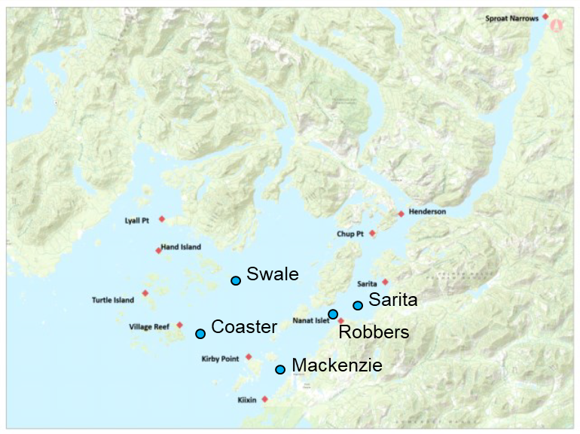
Figure 1. Krill survey sites (blue circles) in Barkley Sound where water samples were collected for biotoxin analysis, and salmon survey locations (red diamonds) including those close to krill survey sites, where juvenile WCVI Chinook were caught and analyzed for biotoxins in gill and liver tissues.

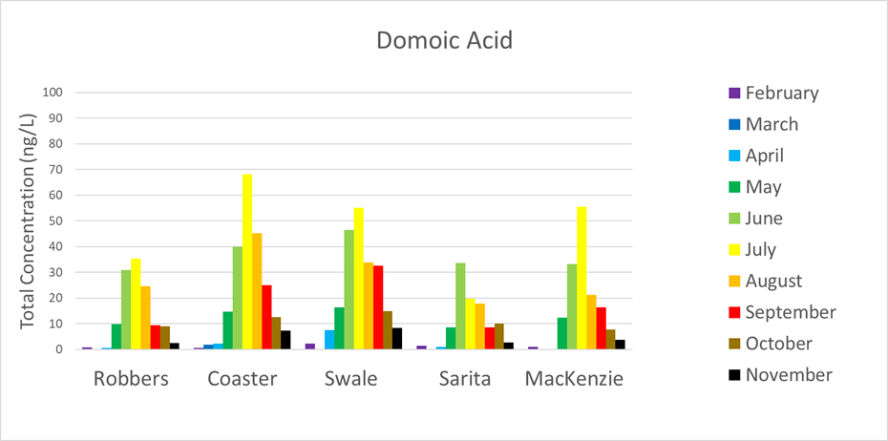
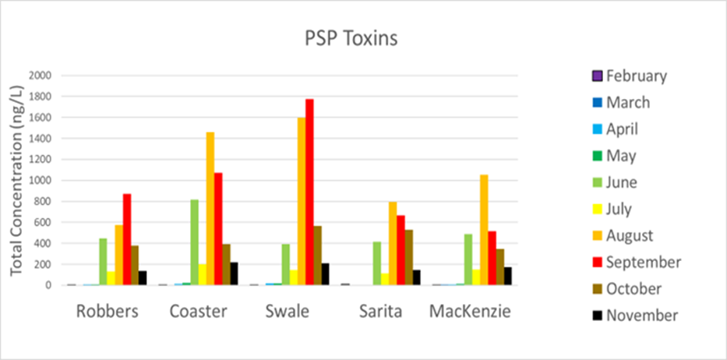
Figure 2. Total concentrations of the harmful algal biotoxin domoic acid (upper panel) and paralytic shellfish poisoning (PSP) toxins (lower panel) at krill survey sites in Barkley Sound during 2024. These toxins, which are known to harm juvenile fish, were most abundant between June and September.

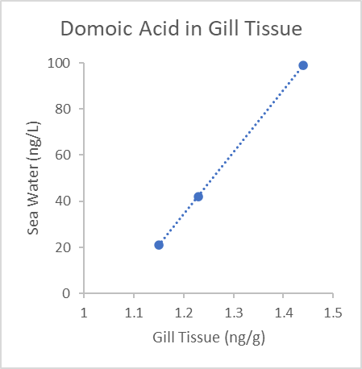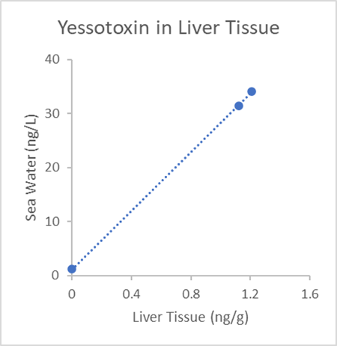
Figure 3. Concentrations in sea water versus gill tissue for domoic acid (left panel) and liver tissue for yessotoxin (right panel) in juvenile WCVI Chinook salmon caught July to September 2023 at Coaster.

📈 References
Include full references for any publications referenced in other sections. Please format references in Harvard style according to Instructions to Authors for the Canadian Journal of Fisheries and Aquatic Sciences, at Canadian Science Publishing.
Lefebvre, K.A., Elder, N.E., Hershberger, P.K., Trainer, V.L., Stehr, C.M., Scholz, N.L. (2005). Dissolved saxitoxin causes transient inhibition of sensorimotor function in larval Pacific herring (Clupea harengus pallasi). Marine Biology 147: 1393-1402. https://link.springer.com/article/10.1007/s00227-005-0048-8

Ross, A.R.S. (2024). Analysis of harmful algal biotoxins in samples collected by the Snuneymuxw First Nation during fall 2023. Report to Snuneymuxw First Nation Marine Division.

Ross, A.R.S., Mueller, M. (2024). Monitoring harmful algal biotoxins in British Columbia coastal waters. PICES Press 32 (2), 37-39. https://meetings.pices.int/publications/pices-press/PICES-Press-2024-Vol32No2.pdf#page=37

Ross, A.R.S. (2025) Seasonal trends in harmful algal biotoxins & salmon enhancement. Fish Health & Hatchery Biology Seminar Series, March 18.

Ross, A.R.S., Loseto, L. 2025. Monitoring biotoxins and contaminants and their impacts on WCVI Chinook salmon. Follow the Fish Newsletter Volume 3, 12 p. https://publications.gc.ca/collections/collection_2025/mpo-dfo/Fs141-15-2025-3-eng.pdf

Ross, A.R.S., Ip., B., Mueller, M., Surridge, B., Hartmann, H., Hundal, N., Matthews, N., Shannon, H., Hennekes, M., Sastri, A., and Perry, R.I. (2025a). Seasonal monitoring of dissolved and particulate algal biotoxins in the northern Salish Sea using high performance liquid chromatography and tandem mass spectrometry. Harmful Algae 145, 102854. https://www.sciencedirect.com/science/article/pii/S1568988325000563

Ross, A.R.S., Mueller, M., Ip, B., Hundal, N., Matthews, N., Surridge, B., Hartmann, H., Nesbitt, B., McKenzie, P., Frederickson, N., Esenkulova, S., Pearsall, I., Sastri, A., Hennekes, M., Galbraith, M., Young, K., Taves, R., Raftery, E., Kafrissen, S., Loro, F. and Perry, R.I. (2025b) ‘Marine biotoxin monitoring in B.C. coastal waters’, in Boldt, J.L., Joyce, E., Tucker, S., Gauthier, S. and Jackson, J. (eds.) State of the physical, biological and selected fishery resources of Pacific Canadian marine ecosystems in 2024. Can. Tech. Rep. Fish. Aquat. Sci. 3687. Nanaimo, B.C.: Fisheries and Oceans Canada, pp. 337. https://www.dfo-mpo.gc.ca/oceans/publications/soto-rceo/2024/pac-technical-report-rapport-technique-eng.html

